**LAB 4 Containers**

**Rutwik Ghag**

Minikube installed on Ubuntu machine

Minikube dashboard

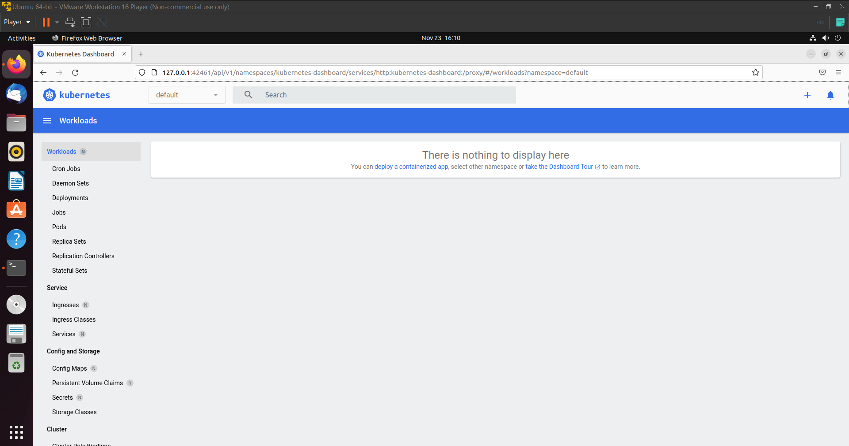

Creating secret to use for mysql deployment

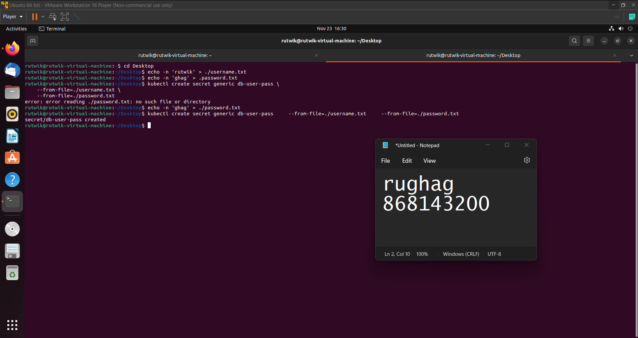

Mysql deployed

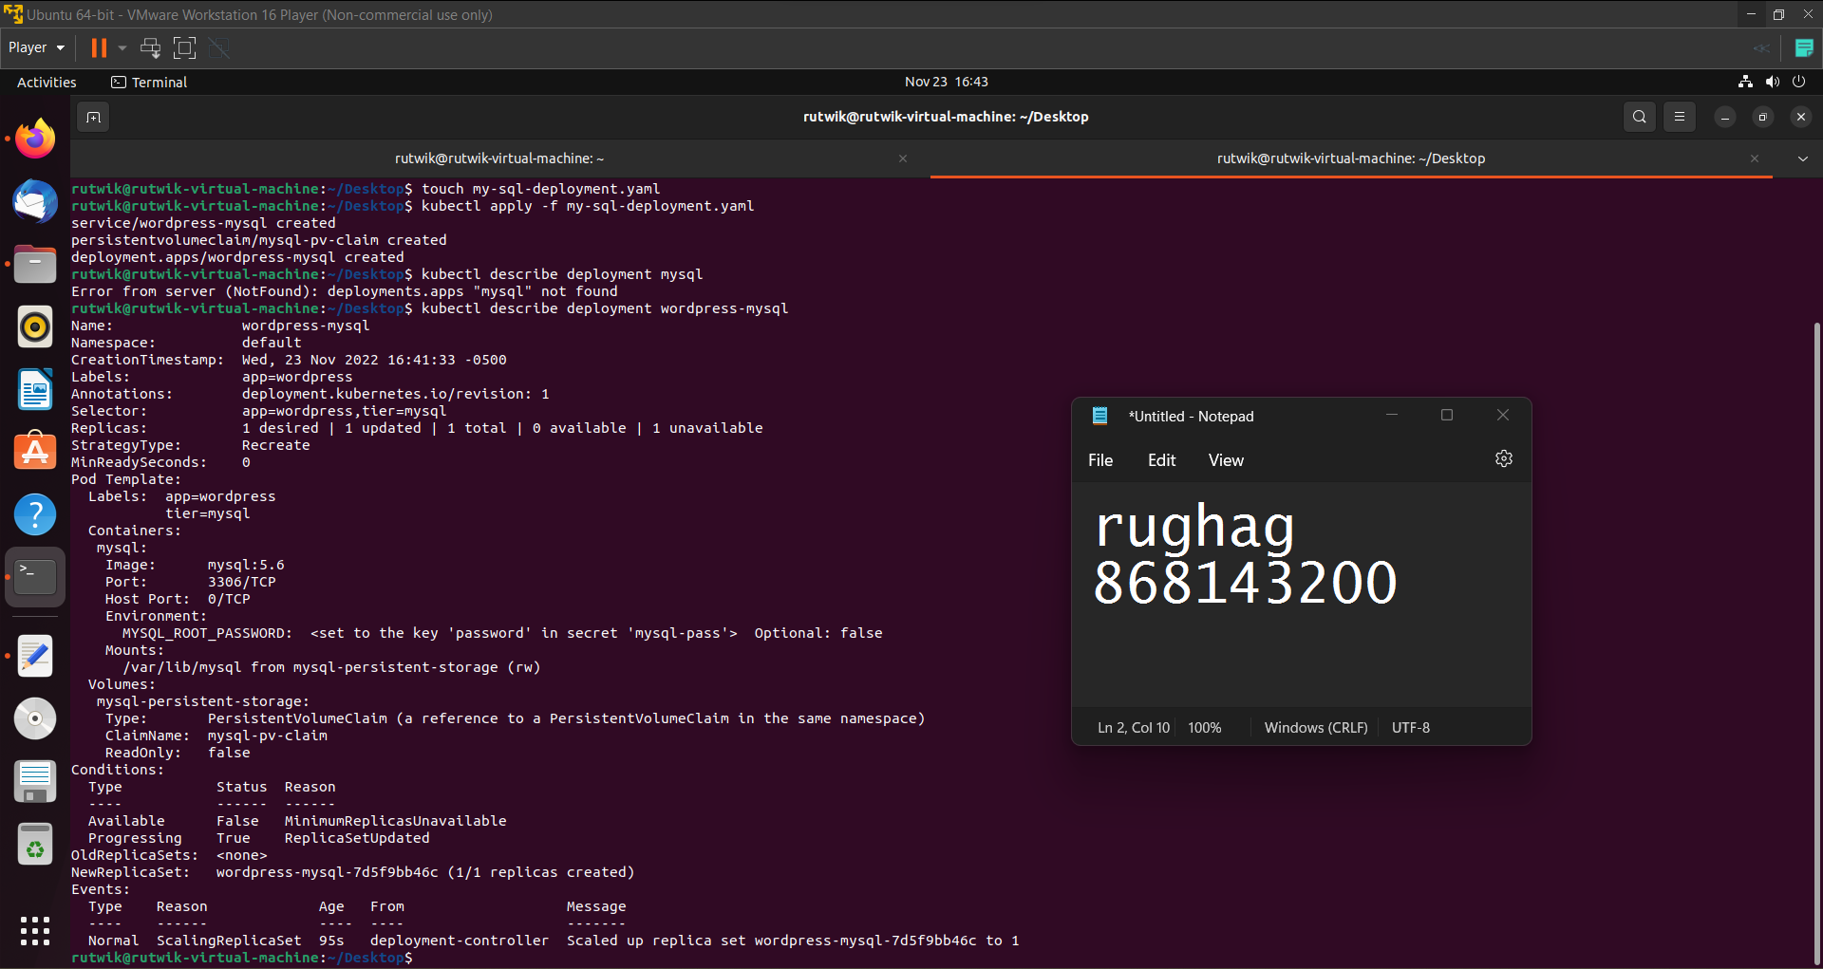

PersistentVolume has been created and bound.

All Pods are running.

Deploying Wordpress from YAML configuration

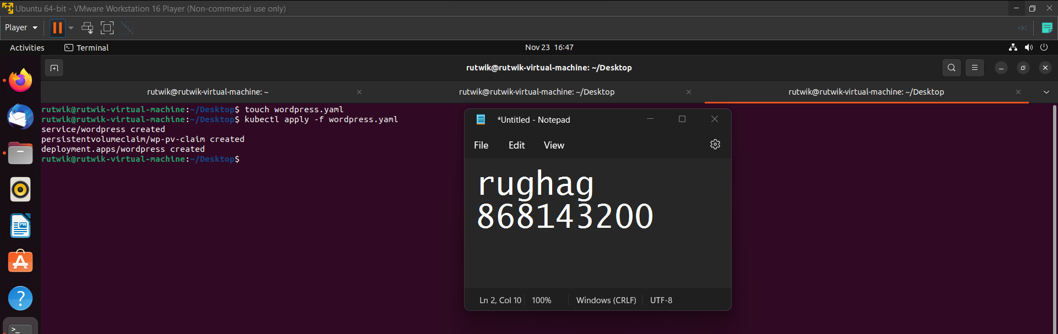

Wordpress deployment

Wordpress URL and Minikube dashboard

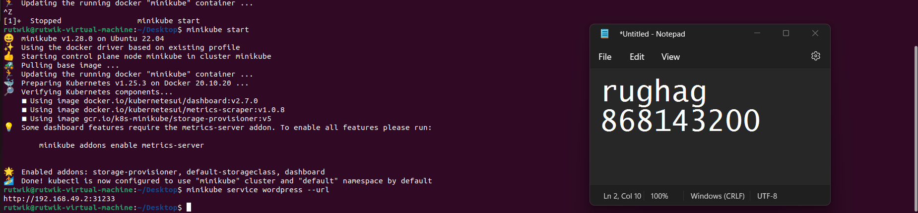

Final Dashboard showing all deployments

